Now we are going to talk about in react native how to get text input value



We will also perform some other operation on it

So basically we are being taught about how to handle text input

So according to the point we need to first make a Text input and then define a state

Because if you want to bring out text input value like clearing the text or print it then you need state it will not happen with the variables then we will apply some style on it

The more we learn style slowly the better it will be for us

I last lesson we were taught basics of the style

We have done it on text input now we will do it on input field

We will eventually will reach advance level and then we will see how we can get its value on the basis on change and later if we want to clear the input box value then how can we do so and in last we will discuss some interview question

Now to add input we type the element textInput

It s an empty element

TextInput is imported from react-native

const [age,changeAge] = useState(22)

  return (

    <View>

<TextInput/>

    </View>

  );

}

When we use it like this the input field is not visible and then we see a blank screen

So we add an attribute or prop here(who knows) that is placeholder

That will tell the placeholder for our input filed

For example in below code

function App() {

  const test ={

    color:'blue',

  }

const [age,changeAge] = useState(22)

  return (

    <View>

<TextInput placeholder='Please enter your email?'/>

    </View>

  );

}

We set the placeholder now in our output we can see our field like below



The textsize inside the input field is still less and it has no border so we need to add styles there

So for that we use style properties like fontSize, borderWidth,borderColor, color etc

<TextInput placeholder='Please enter your email?'

style={{fontSize:18,

  color:'red',borderWidth:2,borderColor:'red',

}}

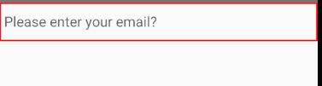

We also add margin to it by margin property whatever value you will give there the value will be set to all type of margin

<TextInput placeholder='Please enter your email?'

style={{fontSize:18,

  color:'red',borderWidth:2,borderColor:'red',margin:10

}}

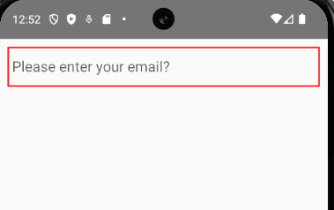

3:00

The style cover very large area of the text editor so we use internal styling instead of inline

Styling with the help of Stylesheet class

We create a innerstyle and cut all the properties in inline and paste it to the innerstyle

As shoen below

function App() {

  const test ={

    color:'blue',

  }

const [age,changeAge] = useState(22)

  return (

    <View>

<TextInput placeholder='Please enter your email?'

style={styles.textInput}

/>

    </View>

  );

}

const styles = StyleSheet.create({

  textInput : {fontSize:18,

    color:'red',borderWidth:2,borderColor:'red',margin:10

  }

})

We add a text component or element inside our component

And then also add state

**Note:-**

In state

You see somthign like it

[]=useState()

It is called destruction in which a set of values (maybe in array)are given to the corresponding values elemnts

In the array(who knows)

function App() {

  const test ={

    color:'blue',

  }

const [name,setName] = useState("")

  return (

    <View>

      <Text>Your name is {name}</Text>

<TextInput placeholder='Please enter your email?'

style={styles.textInput}

/>

    </View>

  );

}

const styles = StyleSheet.create({

  textInput : {fontSize:18,

    color:'red',borderWidth:2,borderColor:'red',margin:10

  }

})

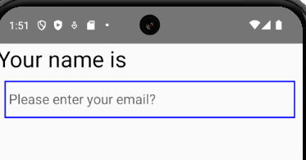

We are not showing any name for now but

Inside usestate you can set the default value of name as anything

But by default we does not give anything so we did leave it with empty string

Whatever name we will give it we give it by our Input Text

Now there is an event handler called onChangeText and it is associated with a textfield but not with a button because we can type tedxt only on in it

It is called when anything is typed on the screen

So in our code we pass it arrow fiunctoin which call setName which will update the state

And our event handler will have a parameter we name it text that will contain everything that

Was types in the inputText

Now our code will look like below

function App() {

  const test ={

    color:'blue',

  }

const [name,setName] = useState("")

  return (

    <View>

      <Text style={{fontSize:30}}>Your name is {name}</Text>

<TextInput placeholder='Please enter your email?'

style={styles.textInput}

onChangeText={(text)=>setName(text)}

/>

    </View>

  );

}

Now whatever we type in textfield will be shown in the label “you name is” as shown below

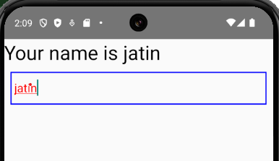

If you are in your PC and if you had focus on your text field then you cannot move out of that focus for that

We need to reload our app

Even if you type from keyboard this will still work

Now we want that there should be button and when it is clicked then everything should be empty in our

InputText element or component

It is very simple such that we add a button element and in its title we name it Clear input value

And then in its onPress event we pass it arrow function which call setName with empty string argument

But this will empty only name in label but not input field so for that we give nsme state to the value attribute of inputField so now it contains state value

Now our code will be like below

function App() {

  const test ={

    color:'blue',

  }

const [name,setName] = useState("")

  return (

    <View>

      <Text style={{fontSize:30}}>Your name is {name}</Text>

<TextInput placeholder='Please enter your name?'

style={styles.textInput}

onChangeText={(text)=>setName(text)}

value={name}

/>

<Button title='Clear Input Value' onPress={()=>setName("")} />

    </View>

  );

}

And output is

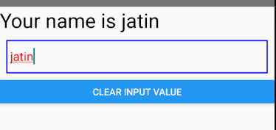

After click on clear input value

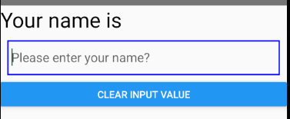

9:30

In Interview you might be often asked to do practical

That how you will handle input box

You can tell we can get the inputbox by value by this way or another way and this way you can make it empty

They may also ask you how you will do styling here

Next question which we will see later that how you can add validation in React native Tell it

You can try it your self that how we can add validation here

That all for this part and in next part we will see form handling

That by making a form how you can bring all the value on the click of a button (who knows)

Because we have handled only one inputbox what will happen if there are more than one